
Internal Penetration Test
Report of Findings

Assessor Name: Waseem Kamal Al-Dawoud
Title: Cybersecurity Trainee at Green Circle
Contact E-Mail: waseemaldawoudpro@gmail.com

Executive Summary: In a simulated scenario, Waseem Aldawoud was part-taking the role of a security consultant contacted by DIVO company representatives with the task of conducting a security assessment on their website and perform a penetration test of DIVO’s internally facing network (LAN) to identify security weaknesses and determine the impact to the company. Upon completion, document all findings in a clear and repeatable manner and provide remediation recommendations.

Approach: Waseem performed an evaluation on DIVO’s internal network topology and company policy and regulations on 3rd of August, 2025. On 5th of August, 2025, Waseem was given permission to initiate passive and active reconnaissance on an IP address, later on he was allowed to actively exploit the discovered website and the testing was performed in a non-evasive manner with the goal to uncover as many misconfigurations and vulnerabilities as possible. Waseem identified and documented each weakness, he was able to exploit two vulnerabilities of privilege escalation, eventually leading to root level access on the web server operating system. 31st of August, 2025, marks the completion of the penetration test.
Scope
IP/Host Address: 192.168.1.67
Description: DIVO Internal Network

Assessment Overview
During the internal penetration test against DIVO, Waseem along with his colleagues identified (2) critical vulnerabilities in outdated Wordpress plugins. Identified as: CVE-2021-34621, CVE-2025-34077. Both exist in the ProfilePress and Pie Register plugins. Both vulnerabilities are critical and score (CVSS: 10) (CVSS: 9.8) in order. Those vulnerabilities compromise the Confidentiality, Integrity and Availability of data. As for network topology, Waseem and his team provided security enhancement recommendations that are within the company budget. Waseem also requested clarity in defined company policies regarding security awareness and requirements.

Even though the website had user registration disabled, the tester found the vulnerabilities to still work and are not patched. By exploiting the ProfilePress plugin vulnerability, the tester was able to create an admin level account on the Wordpress site. This allowed him to upload plugins, edit themes and inject malicious code. The tester attempted to exploit the first and most critical vulnerability at first using Metasploit, but his attempts were deemed unsuccessful. However, the tester found a publicly available Proof of Concept (PoC) code that can be used as a malicious exploit for the ProfilePress vulnerability. The tester generated a shell script, amended the code to his desired target and once executed, an admin account with the name “Waseem Aldawoud” was created on the site.

After a brief exploration of the website and its capabilities. Waseem created a malicious plugin acting as a reverse shell to establish a connection between his device and the web server, he uploaded the plugin using his admin account and set a trigger for the connection (?revshell=1) in url.
The tester successfully established a reverse shell connection after activating and triggering the malicious plugin. He was inside the web server as www-data user. Waseem was able to discover a wp-config.php file located in /wordpress/ directory, this file was readable by www-data, and it contained critical database connection information such as: host, database, username, password). This discovery indicates that attackers could easily dump or steal website data. Waseem was able to retrieve all the accounts that were registered on the site with their hashed passwords and ‘dumped’ them in a file on his system.

However, Waseem started looking for ways for privilege escalation to fully hijack the server, he must have root level access. After investigating, Waseem discovered that the user www-data had no writable or permissions to execute or run files or scripts that are on the system. He was only able to write and execute files located in /wordpress/ directory.

Using social engineering and guessing, Waseem retrieved a list of users on the system and discovered 3 potential target users to move onto. Since www-data had very limited permissions, he had to resort to lateral movement and try a different user account. He discovered the following user accounts on the system (divo, pentest, externalwebapp) he then tried to guess one of the user accounts (divo) and used the same password used for the database. Luckily and to his surprise, he was able to change his user account from www-data to divo.
Once in divo user, Waseem once again enumerated the system, searching for privilege escalation attack vectors. He discovers a find binary, and using GTFO binaries, it was revealed that the attack vector is exploitable by executing a certain command using the find that’d give us root level access.
Waseem executed this file and successfully hijacked the system, gaining root level access on the entire web server marking the end of his tests.

Summary of Findings

CVE | Severity | Vector | Outcome | Patch
2025-34077 | 10.0 | Remote | RCE | Update Plugin
2021-34621 | 9.8 | Remote | Admin Account | Update ProfilePress

*Note: Not all vulnerabilities were noted as the website contained plenty of vulnerabilities, I listed the most critical ones, especially the one that eventually led to root level access.

Walkthrough
- Passive and active reconnaissance: I pinged the host and ran a few commands to determine the nature of the host for info gathering purposes. For this, I used ping and whois for passive recon. I also used Nmap, Gobuster, Nikto, WPScan for web enumeration and aggressive scanning. I also explored the website to figure out the nature of the site itself, though this wasn’t really useful.
- Exploitation and Privilege Escalation: I attempted to exploit vulnerability CVE 2021-34621 by using tools such as Metasploit and BurpSuite. However, it’s important to note that I discovered later that these tools aren’t necessarily needed for the test, instead, I searched for a proof of concept code and constructed a malicious shell script, the purpose behind the script is to create an admin account. CVE-2021-34621
- Exploitation and Reverse Shell: Upon creating an admin account, and gaining access to the site editor, my next action would be to establish a reverse shell connection. I created a script that serves as a malicious plugin to be uploaded onto the website using the admin account I had created. Also in order to not break the site, the script had to be triggered using a special URL parameter (?revshell=1) and also for extra insurance I made it run in background. I set up a listener and successfully got inside the system.
- (Extra) Database Dumping: I obtained access to the system as www-data user, I was able to read files in /wordpress/ directory, you’ll find a wp-config.php file that you can read. It contains critical connection information to the MySQL database that the site runs on. You can then use it to connect to the database and dump (or steal) the data.
- Linux Privilege Escalation: Our main goal is now to fully hijack the system, in order to do that if you initiate a sequence of commands to investigate your current user and its permissions, you’d discover that www-data has no read/write/execute permissions outside of /wordpress directory, therefore we had to laterally move to a different user. When you run cat /etc/passwd you’ll find 3 more users on the system (divo, webexternalapp, pentest). In my case, I guessed the password for divo to be the same password for the database and when I tried to su divo, entered database connection password it successfully changed my user to divo. Now, redo the sequence of enumeration and you will discover that divo has a binary file located in /usr/bin/find that you can execute as root. Once exploited, you’ll gain root level access and successfully hijack the system. Refer to GTFO binaries.

Attack Chain Screenshots:
Reconnaissance and web enumeration
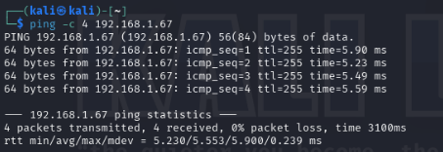
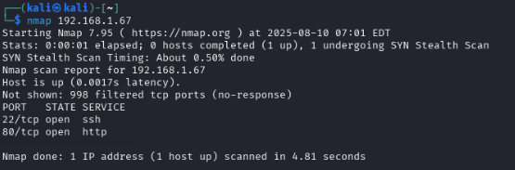
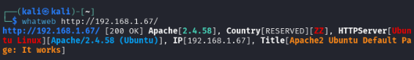

WPScan
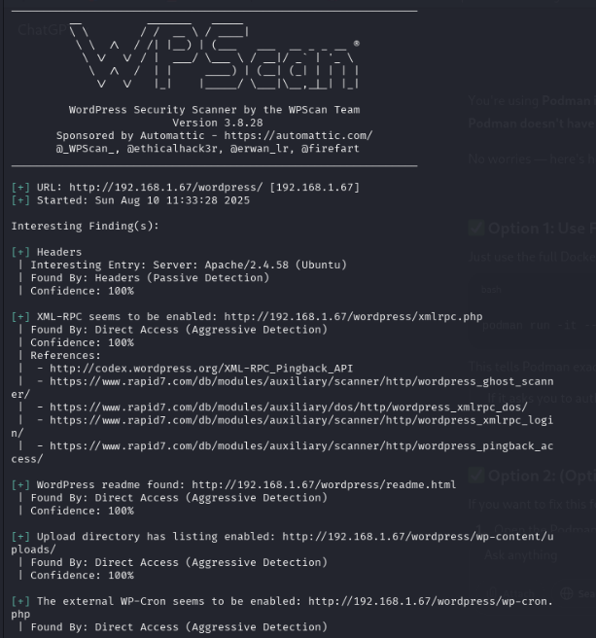

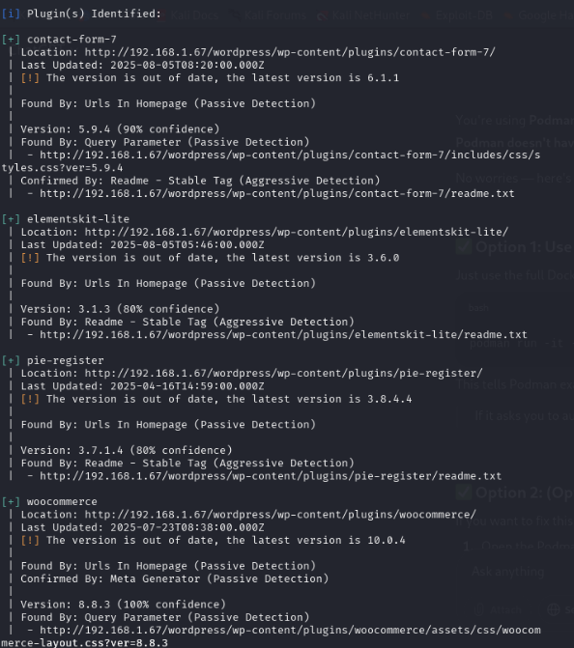
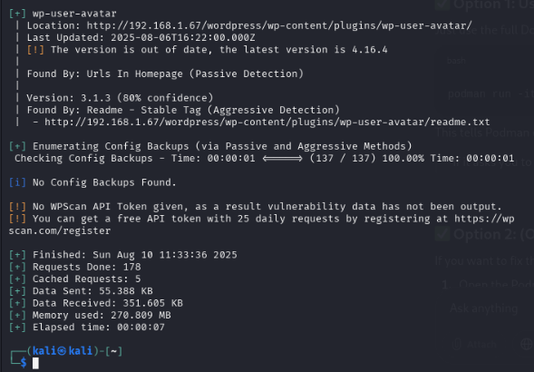

Exploitation and Privilege Escalation:
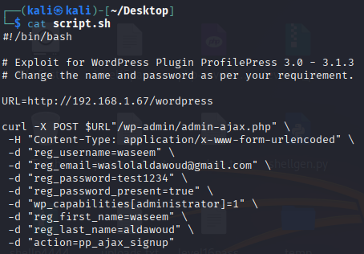
Reverse Shell Plugin PHP Code:
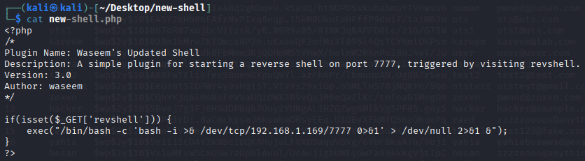
Information gathering as www-data:
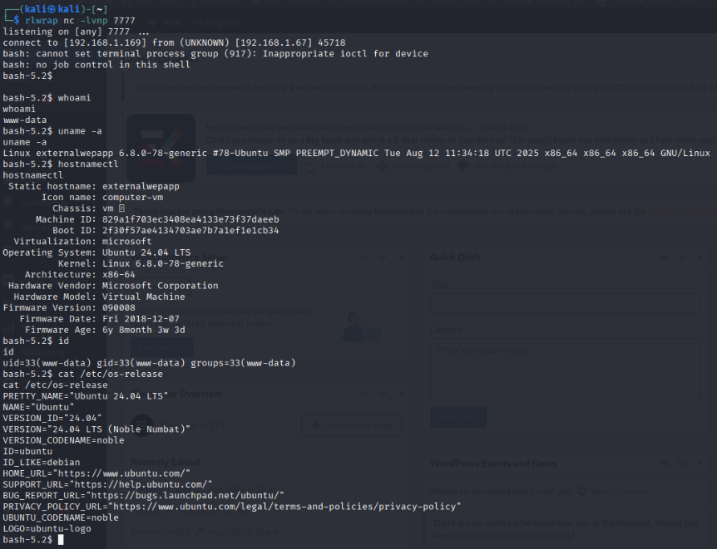

WP-config.php file Database Connection Credentials:
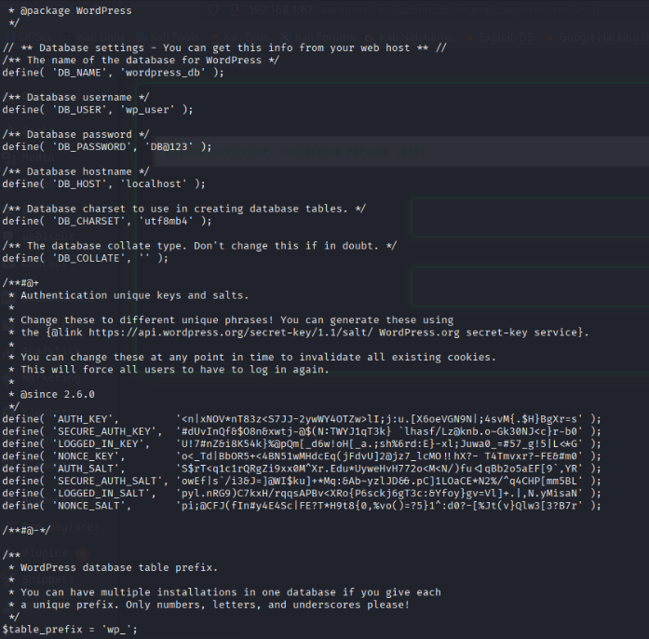

Database Enumeration and Dumping (Optional)
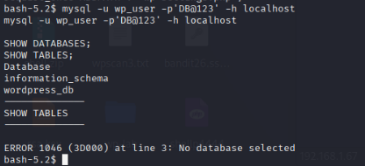
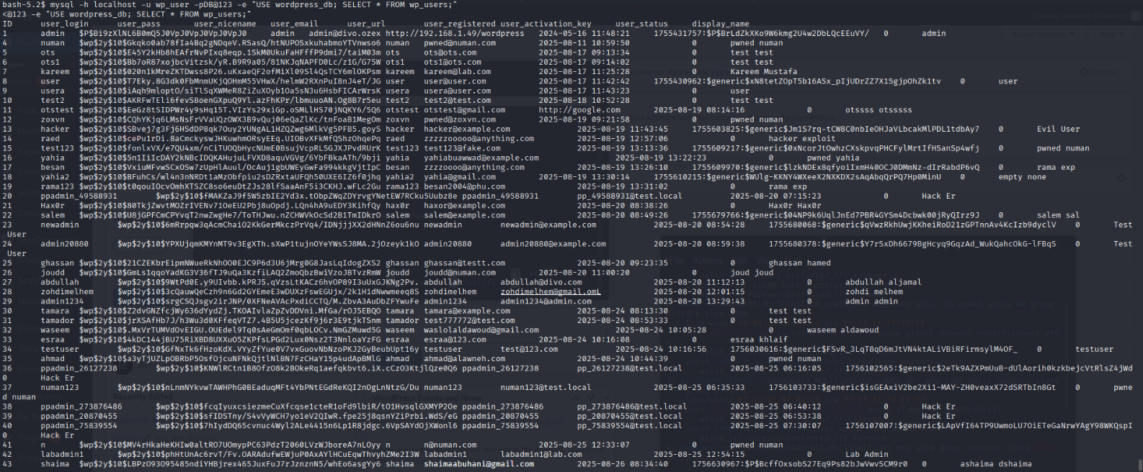

Reading /etc/passwd (Privilege Escalation to root)
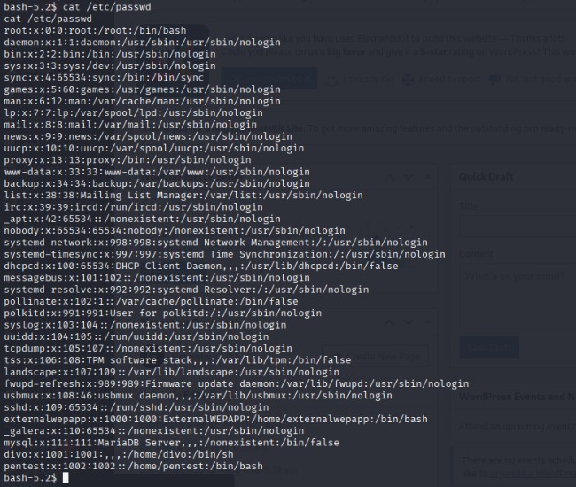
Lateral Movement and hijacking divo user:
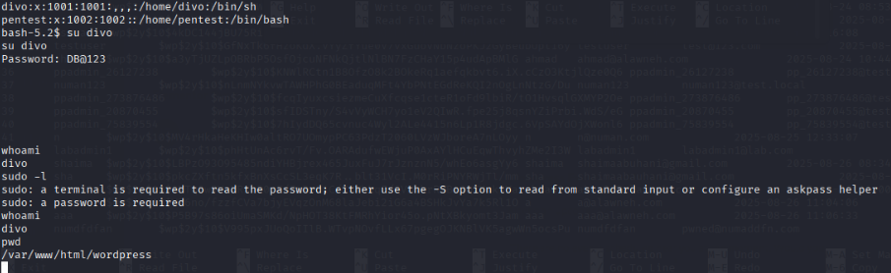
Further information gathering about divo user:
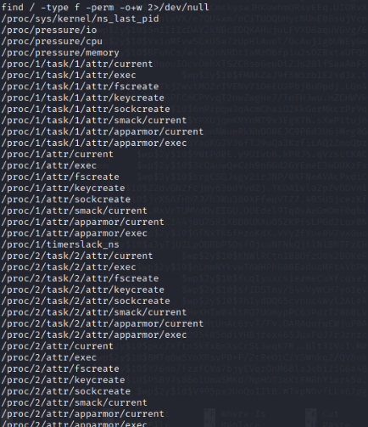

Using /usr/bin/find to obtain root level access and hijack system:
